CONFIDENTIAL CS/OCT 2026/MAT133

UNIVERSITI TEKNOLOGI MARA FINAL EXAMINATION

COURSE
COURSE CODE
EXAMINATION TIME
PRE CALCULUS
MAT133 OCTOBER 2026
2 HOURS

INSTRUCTIONS TO CANDIDATES

- This question paper consists of 5 questions.

- Answer ALL questions in the Answer Booklet. Start each answer on a new page.

- Do not bring any material into the examination room unless permission is given by the invigilator .
- Please check to make sure that this examination pack consists of: i) the Question Paper
  - a one - page Append ix 1
  - an Answer Booklet - provided by the Faculty
  - a graph paper - provided by the Faculty

- Answer ALL questions in English.

/

DO NOT TURN THIS PAGE UNTIL YOU ARE TOLD TO DO SO

This examination paper consists of 6 printed pages

QUESTION 1
a) Write the solution of 3x - 7 > -8 in interval notation and on a number line.
(3 marks)
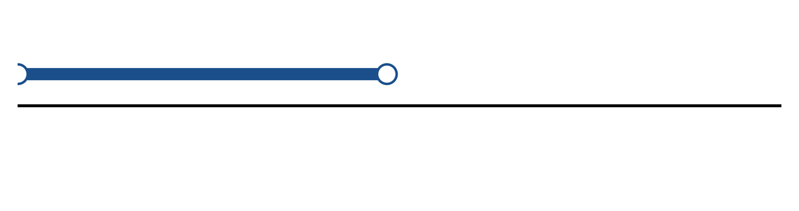
Figure: solution set.
b) Solve the inequality |2x - 3| > 3. Express the answer in interval notation and on a number line.
(5 marks)
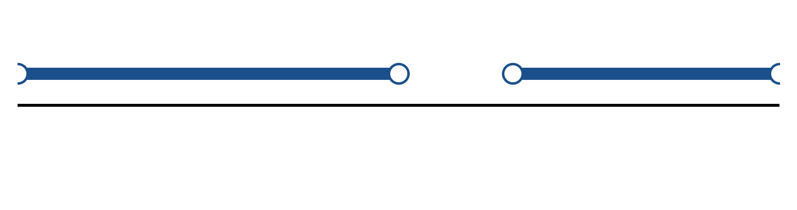
Figure: solution on a number line.
c) Solve the equation |4x + 5| = 2.
(4 marks)
QUESTION 2
a) Apply graph-transformation techniques to sketch y = 2(x - 1)² - 6. State the vertex and the y-intercept.
(5 marks)
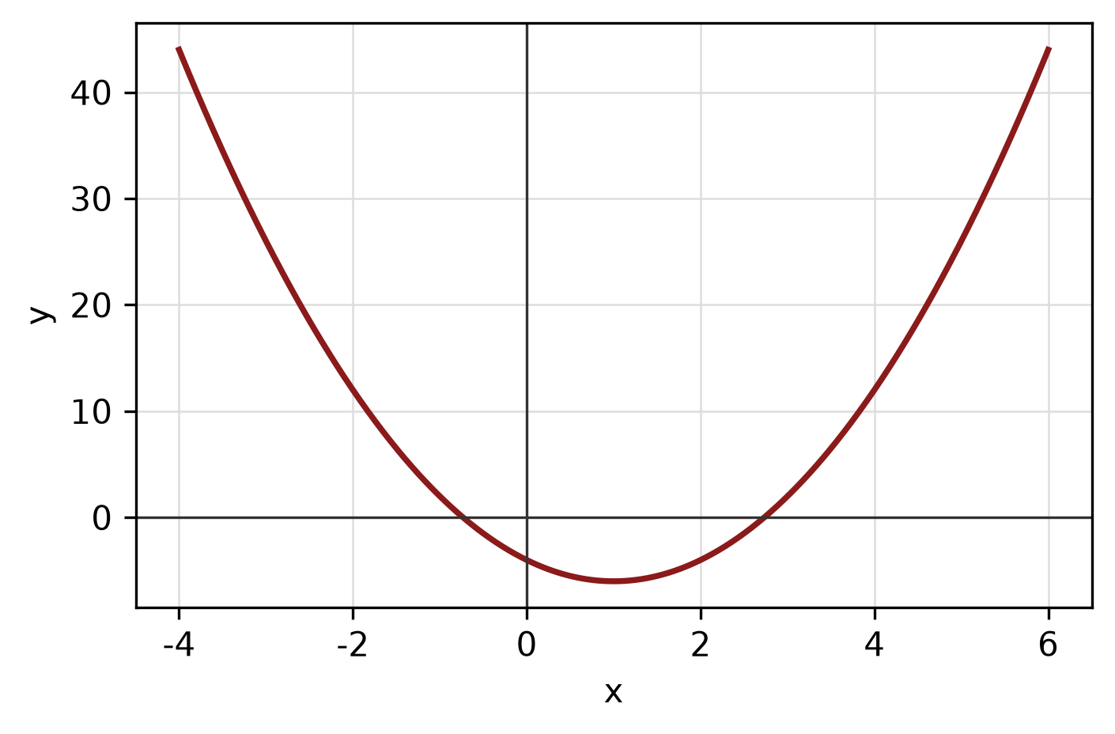
Figure: transformed graph.
b) The piecewise function is defined by
f(x) = x - 2, if x < -1;
f(x) = -1, if -1 ≤ x ≤ 2;
f(x) = x² + 1, if x > 2.
Sketch the graph and find f(-2), f(0) and f(3).
(5 marks)
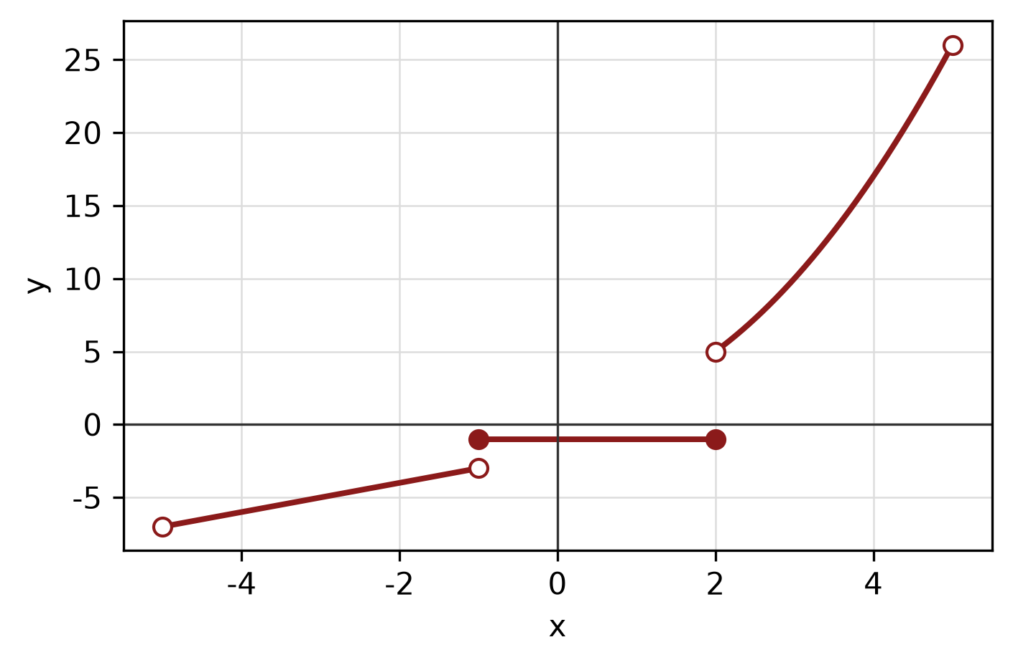
Figure: piecewise graph.
c) Find the equation of the straight line passing through (-5, 3) and (5, -4).
(4 marks)
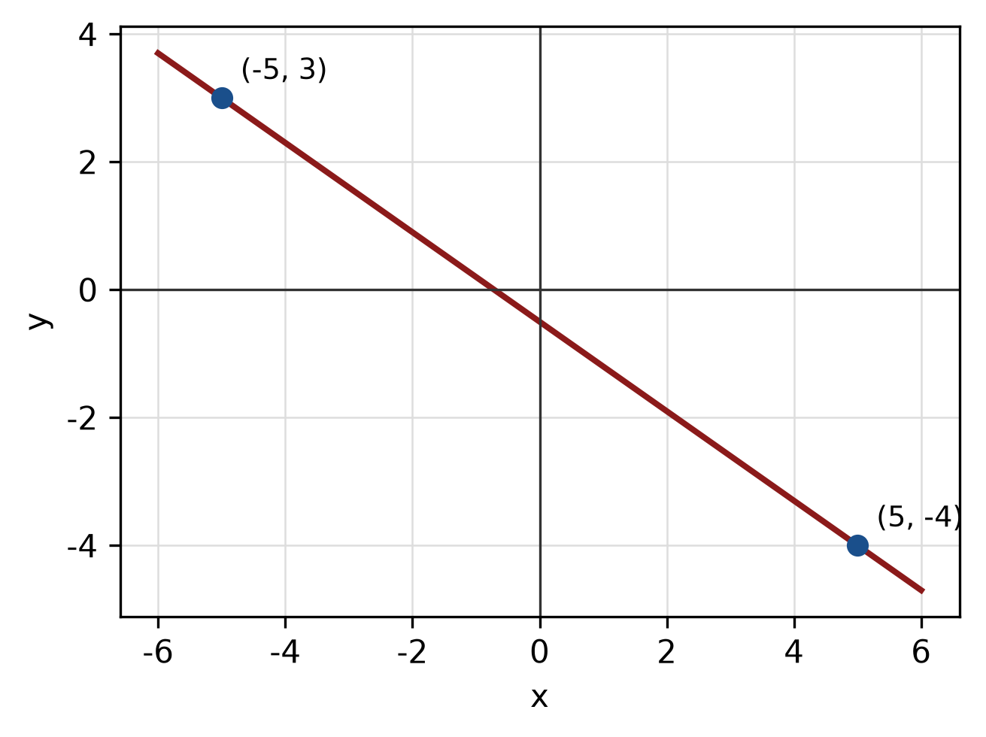
Figure: line through the two points.
QUESTION 3
a) Given z₁ = -1 - 4i and z₂ = -4 - 2i, find z₁ × z₂ in the form a + bi.
(4 marks)
b) Find the modulus and argument of z = -5 + 12i. Give the argument in degrees correct to one decimal place.
(5 marks)
c) Express log_5(5) + log_5(5) as a single logarithm and evaluate it.
(3 marks)
QUESTION 4
a) Solve the simultaneous equations
x + 2y = 1
5x - 5y = 20.
(4 marks)
b) Graph the system of inequalities below and shade the feasible region. State the vertices of the region.
x ≥ 0, y ≥ 0, 2x + 2y ≤ 5.
(5 marks)
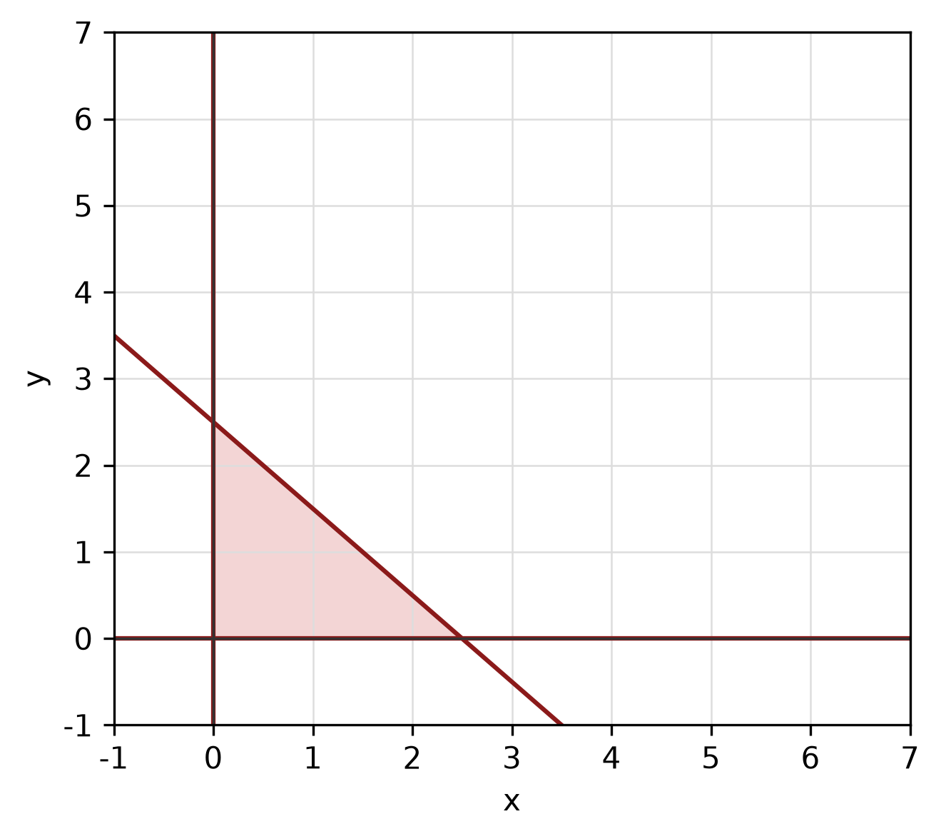
Figure: feasible region.
c) Find the standard equation of the parabola with focus (2, 1) and directrix y = 5. State its vertex.
(5 marks)
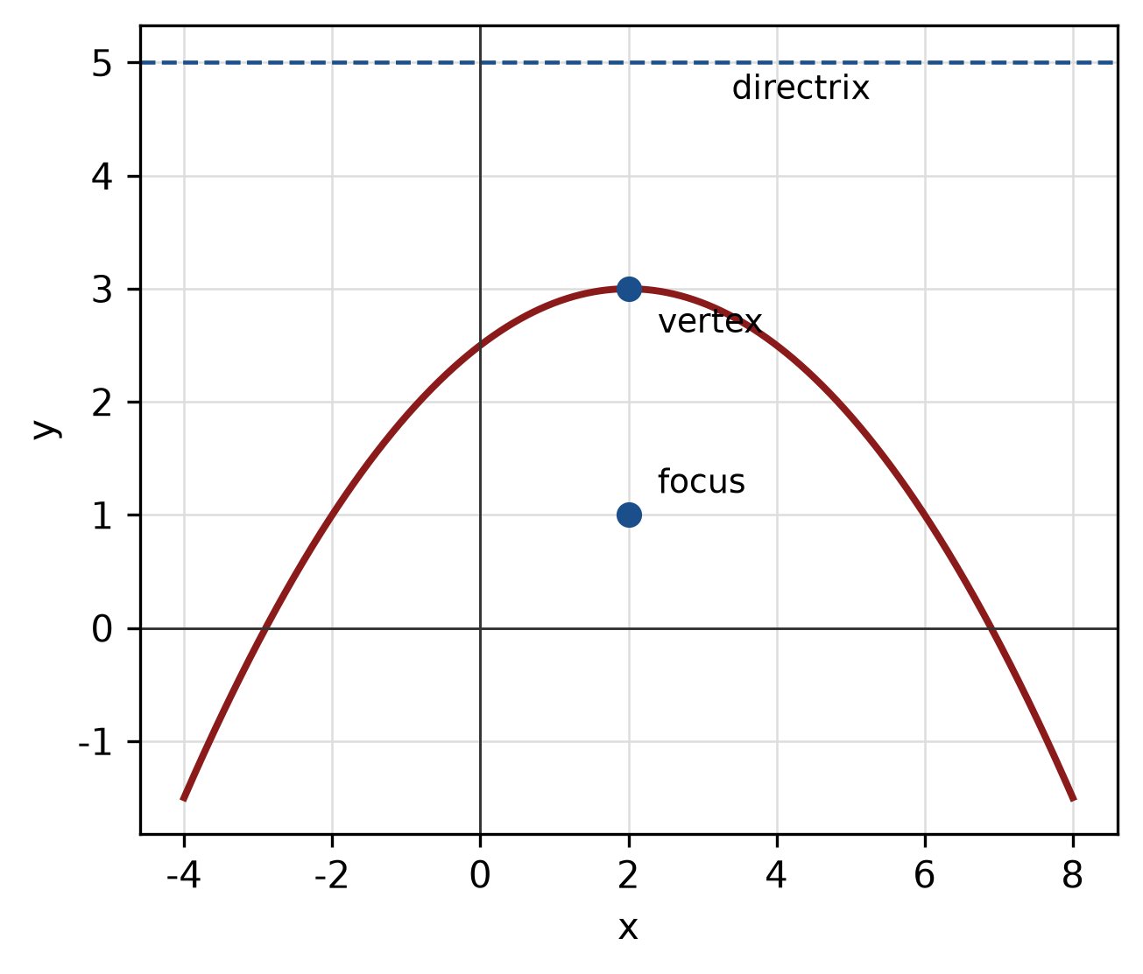
Figure: parabola with focus and directrix.
QUESTION 5
a) Prove the identity sin² x/(1 - cos x) = 1 + cos x.
(5 marks)
b) Find the area of the sector of a circle with radius 8 cm and central angle 120°.
(4 marks)
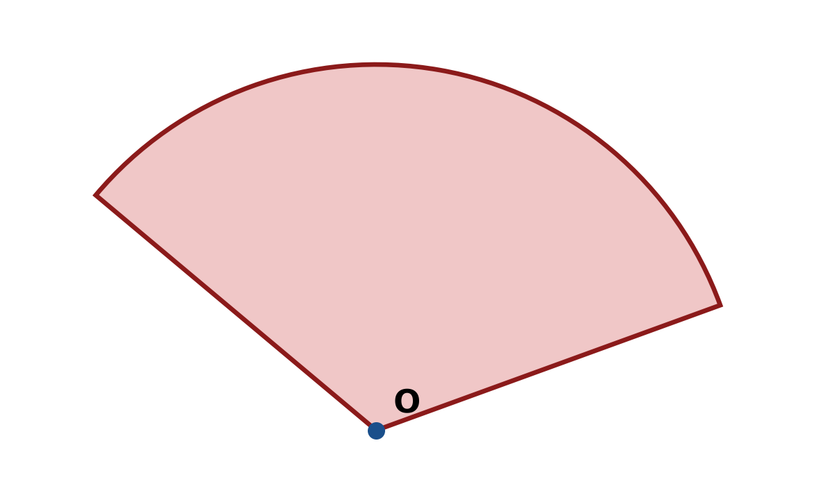
Figure: sector.
c) In triangle ABC, A = 45°, B = 60° and a = 13 cm. Use the sine rule to find b.
(4 marks)
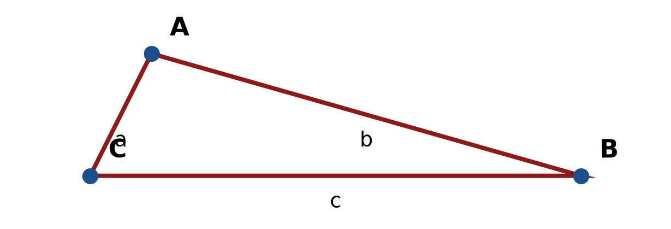
Figure: triangle ABC.
END OF QUESTION PAPER

APPENDIX 1
Formula sheet (as supplied with the paper).
sin² A + cos² A = 1 | tan² A + 1 = sec² A
sin(A + B) = sin A cos B + cos A sin B | tan 2A = 2 tan A / (1 − tan² A)
cos(A + B) = cos A cos B − sin A sin B | Arc length, s = rθ
tan(A − B) = (tan A − tan B) / (1 + tan A tan B) | Area of sector = ½r²θ
cos 2A = cos² A − sin² A | a / sin A = b / sin B = c / sin C
cos 2A = 1 − 2sin² A = 2cos² A − 1 | a² = b² + c² − 2bc cos A
sin 2A = 2 sin A cos A | Area of triangle = ½ab sin C

